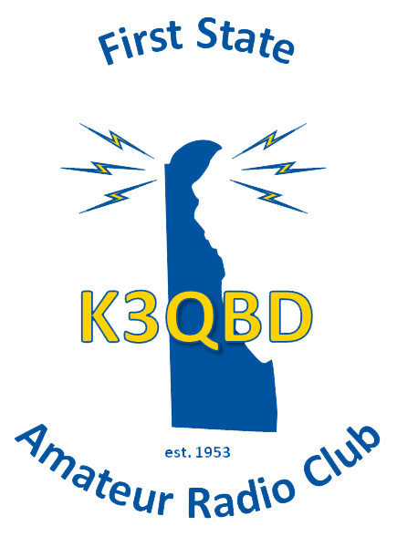

First State Amateur Radio Club
Membership Application

Please fill out the application, below, and return it to the attention of FSARC Club Secretary, P.O Box 1050 Newark, DE 19715-1050.

Dues are $20.00 per year and payable at first meeting. The club Treasurer will pro-rate the dues for a portion of a year. PLEASE DO NOT SUBMIT DUES UNTIL YOU ARE NOTIFIED OF MEMEBRSHIP APPROVAL.

Name _____________________________________________ Call_______________

Address_______________________________________________________________

City ____________________________ State _____________ Zip _______________

Home Phone:_(____)__________________ Cell Phone: _(____)__________________

Email:______________________________

Would you care to have your email included in the FSARC Email Google Group. Emails sent out by the group are generally limited to topics of general ham interest and information specifically for club members. Yes No (please circle one)

Are you An ARRL Member? Yes No (please circle one)

License Class: __________

Once accepted for membership, I agree to abide by the Constitution and by-laws of the First State Amateur Radio Club.

Signature: ___________________________________ Date: ____________________

